Testing & Junior Training Days at Lake Maraetai Mangakino: 15-16th October 2022
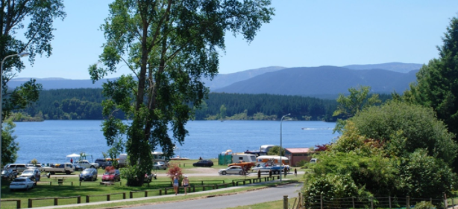
Open to all classes:
START TIME: 9.30am both days
Medics and safety teams on site both days
Please make sure you have a current ROW, Boat registration and Race License as these expired in September. (ROW) we will try and get some done on the day if required.
Standard entry fee is $100 PER DAY - 16 years and under are FREE
Internet banking to NZGP Hydroplane Drivers Club: BNZ 02-0100-713382-00. (Don’t forget to use your name as reference.) Or pay on the day.
Please R.S.V.P to: Denise Preece: denise@accelerationonwater.co.nz or mobile 0272503504 so we have some idea of numbers.

