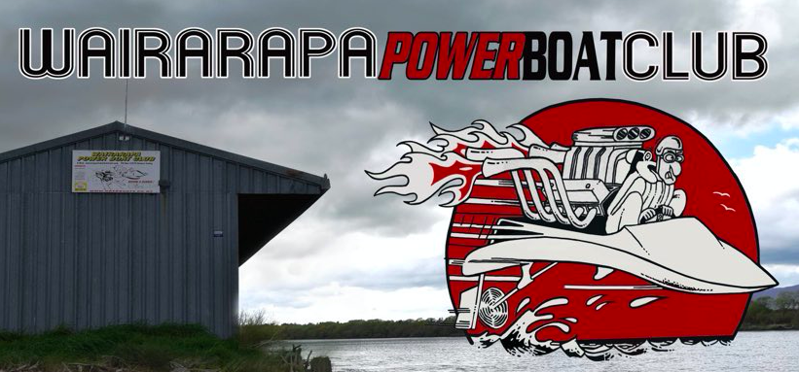

2023 Major Regatta
4th & 5th March 2023
Ruamahanga River Diversion

Boat Name ___________________________________
Driver Name __________________________________
Class ______________________________
Phone Number ______________________

Titles Contested (tick to enter)
NI Clubman ____
NI Prostock 90 ____

ENTRY FEES
Junior Entry Fee $60
Standard Entry Fee $120

Total Paid $_______

Payments to 02 0688 0095879 000
(please use your name and boat name as reference)

Send entries to
WairarapaPBC@yahoo.com or send a photo of entry to Jeremy Thomas

Eftpos available on site | ‘SPEEDY’ Burgers - Saturday night
Free camping on site | Drinks available
Bonfire | NO Crane, sorry

